Bahria University,

Karachi Campus



LAB EXPERIMENT NO.

4

LIST OF TASKS

|  |  |
| --- | --- |
| TASK NO | OBJECTIVE |
| 1 | On Cisco switches, where is the running configuration loaded from? |
| 2 | What does the flash memory on a switches store? |
| 3 | When you are logged into a switch, which prompt indicates that you are in privileged mode? |
| 4 | On which modes in Cisco's IOS you can issue show commands? |
| 5 | Create two users Admin_'yourfirstname' and Admin_'yourlastname' grant all privileges to them then login by using Admin_'yourfirstname' then remove (Admin_'yourlastname'). Clearly show command for every step |
| 6 | Show the encrypted console password, Privilege mode passwords and all user’s passwords. |

Submitted On:

18-OCT-2023

(Date: DD/MM/YYYY)

**LAB 04 CISCO IOS CLI & BASIC SWITCH CONFIGURATION**

1. On Cisco switches, where is the running configuration loaded from?

The running configuration on Cisco switches is loaded from the RAM (Random Access Memory).

1. What does the flash memory on a switches store?

Flash memory on a switch stores the switch's operating system and system files.

1. When you are logged into a switch, which prompt indicates that you are in privileged mode?

The prompt that indicates you are in privileged mode on a Cisco switch is the '#' symbol.

1. On which modes in Cisco's IOS you can issue show commands? in 2 lines only

You can issue 'show' commands in both user EXEC mode and privileged EXEC mode in Cisco's IOS

(5)Create two users Admin_'yourfirstname' and Admin_'yourlastname' grant all privileges to them then login by using Admin_'yourfirstname' then remove (Admin_'yourlastname'). Clearly show command for every step.

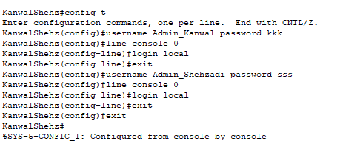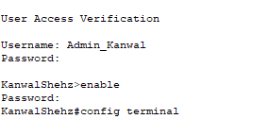

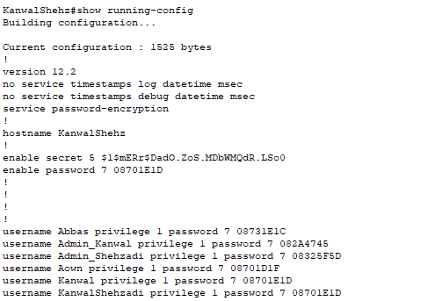

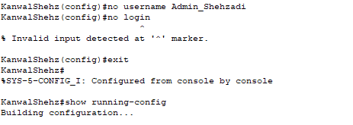

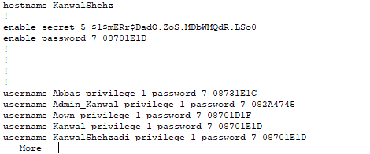

(6) Show the encrypted console password, Privilege mode passwords and all user’s passwords.

**Console Password**

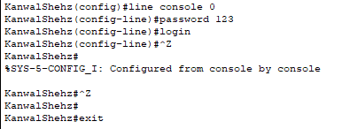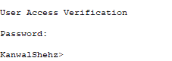

**Privilege Mode Password**

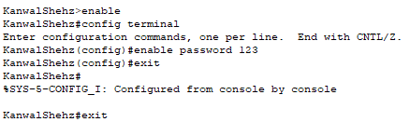

**Privilege Mode Encrypted Password**

